**Custom Phone Field with International Telephone Input**

**Prepared By**

Florentino Aryo Widyantoro,

Technical Consultant

Result Example:

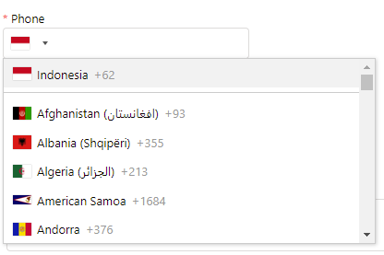

How to:

1. Download Input-Tel Plugins from <https://github.com/jackocnr/intl-tel-input/releases>
2. Upload to SF as static resource
3. Detailed example code can be found here: <https://github.com/FlorentAryo/SF-Rep/tree/main/Custom%20Phone%20Field%20with%20International%20Telephone%20Input>.

References:

https://github.com/jackocnr/intl-tel-input